p
Lakeside Regional Church – Communication Card - 11/5/2017
Name I am: 1st Time Guest 2nd Time Guest
Address Regular Seasonal Update my Info
Decisions/Needs: Committing my life to Christ
Phone Receive Prayer / Weekly Reminder Emails
Email Prayer Request: Confidential Add to Email
Child(ren)

Birthday/ Anniversary
Would like to: Become a Member Join a Life Group Be Baptized Volunteer in a Ministry
*** Please place in offering plate. Thank you!

Upcoming Events and Activities
Connect
- Woman’s Breakfast: November 11th at the Hague Campus.
- Join a Life Group Today! Imagine a place where you are wanted, needed and accepted. A place where everybody knows your name, where friendships are real and where you are challenged and empowered. A place where you become stronger and part of a team. Next steps were never meant to be taken alone. Contact Kellie Bilow at kelliebilow@gmail.com or 518-323-5202
- Youth Meeting Tonight! At Russell and Gabby’s house. 5:30 to 7:30.
Grow
- Building Project: Roger Houck discussed the building Project on Sunday Oct 22 2017. Those who missed his presentation can view it in our sermon archives starting at around 29 minutes in. The link is https://www.sundaystreams.com/go/lakesideregionalchurch.
- Get Involved! God has placed a gift within you to be used in service to Him – it’s how we grow as Christians - let us know you are ready and we will help you identify what it is and enable you to use it for God’s glory. Contact jtockrin@gmail.com or 518-588-7094

Serve
- Operation Christmas Child – Brings good news and great joy to children all over the world through simple gifts. Packed boxes due by Sunday Nov 12th, and the Kid’s Annual Packing party will be Sat Nov 11th from 2;00 to 4;00 PM at the Best Western. Questions see Cam Brown, Ray Thatcher, or April Reeder.
- Puppet Ministry! Adam Huestis has formed a puppeteer group to engage children with godly principles. No skills are required to join. Let him know you are interested at huestisa@hotmail.com.

If you cannot make it to Sunday service or if you
missed a service, view it online.
http://www.sundaystreams.com/go/lakesideregionalchurch

We now offer a convenient and easy way to make a donation online. Simply go to
www.lakesideregionalchurch.org
and click on “Donate”.

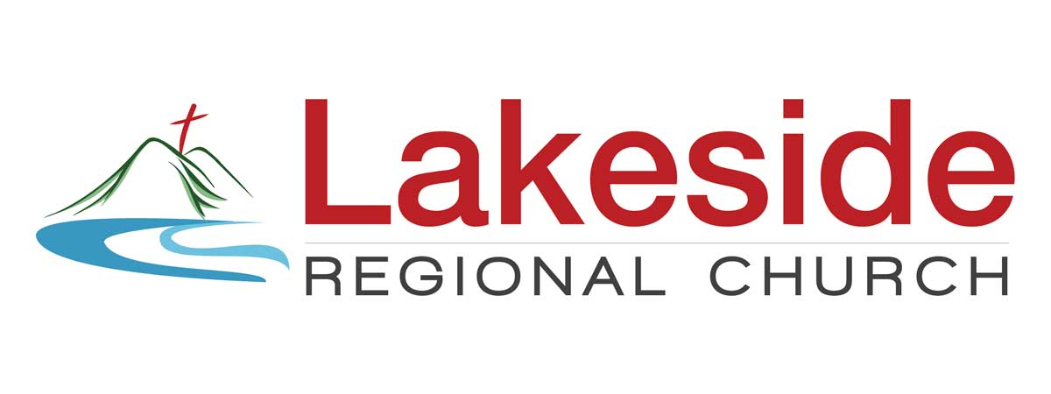
Connect, Grow, Serve…
Sunday, November 5, 2017 - 10 A.M. Worship Service

Welcome!
New to our church? We are so glad you came!
Please fill out your contact information on the communication card so we can get to know you. Children's Church available for children ages 3 – 9! There is also a Nursery & Toddler room available for infants to 2 years olds.

“The greatest among you will be your servant” Matthew 23:1
Looking for ways to connect and serve?
Please consider the following areas:
- First Impressions Team – Greeters, Ushers, Kitchen Crew
- Sunday School and Childrens Church
- Music Team
- Life Group Leadership
- Building, Grounds and Maintenance

Mission Statement: Lakeside Regional Congregation exists to honor God by making more disciples for Jesus Christ.
Vision Statement: With God’s direction LRC members will lead people into a relationship with Jesus Christ, and touch many individuals at least once with His love.



Current Life Groups
Make a commitment to invest in your personal growth. If you are not part of a Life Group, we encourage you to get connected. A list of available Life Groups are listed below. Let's be there for each other and start doing life together!

- Crown Point/Ti: Meeting date will vary depending on group participant schedules – please call ahead to confirm – 6:30 PM – John and Nancy Ockrin – 597-3754 – jtockrin@gmail.com At the Ockrin House, 989 Stoney Lonesome Road, Crown Point, NY.
- Ticonderoga: Weds. 6:30 PM – Todd and Kellie Bilow – 503-4504 kelliebilow@gmail.com At the Bilow House, 45 Outlook Dr., Ticonderoga, NY.
- Port Henry Young Adult Group: Sun. 6:30 PM Chuck and April Reeder – 942-3311 – areeder@moriahk12.org At the Reeder’s House Broad St., Port Henry, NY.
- Pure Desire Group: (For Men Only) Sundays 8:00am – Dan Ockrin 518-597-3754. Meeting upstairs before services at the Hague Campus, and will meet at the Ti Office on Best Western Sundays.
- Experiencing God Group: Tuesday 5-7 PM - at the Gadjo’s house -75 Pumpkin Hollow Road, Adirondack, NY 12808. Contact Abe or Erin Gadjo at 518-494-7611 for more information.
- Young Mothers Group: Brant Lake: Thursday, 6:30 to 8:30 pm. This will be every other Thursday. Contact Pat Proietti at 518-681-9838 or Liz Millington at 518-832-0254 for more information.

For Prayer Requests/ Updates:
If you would like to receive our prayer request emails, you can either email Kayla Thompson at info@lakesideregionalchurch.org or go to our website www.lakesideregionalchurch.org & click on the 'about' tab and join our mailing list. If you want to have an actual prayer request sent out, email us at info@lakesideregionalchurch.org.
To post announcements, send an email to both John Ockrin at jtockrin@gmail.com for bulletin, and Kris Stonitsch at kstonitsch@gmail.com for the slideshow. Requests for announcements should be sent no later than Wednesday night of the week you would like it to be included in the bulletin or slide show.

www.lakesideregionalchurch.org

Pastor Skip Trembley

LRC: Campus
9803 Graphite Mtn. Road
Hague, NY 12836
543-4594
ALL MAIL SENT TO:
PO Box 111
Ticonderoga, NY
12883

LRC: Office
106 Montcalm St.
Ticonderoga, NY 12883
543-4400

