Attention Ladies!!
Our Annual Church Woman’s Outreach Brunch Will Be Held on Saturday March 10th at 11:00 AM this year
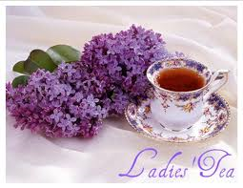

WE NEED YOU To:
- Pray
- Come and bring a friend who needs God
- Sign up for food donation with Nancy Millington
- Bring to Church appropriate gift bag items:
  - Hard cover Christian Books
  - Pretty notecards/stationary
  - Fancy Pens
  - New or almost new jewelry
  - Scarves, candles, hand knit items
  - gourmet coffees, teas, chocolates, candies,
  - new toiletries such as fancy soaps, shampoos, conditioners, body washes, gels, hair décor
  - new or almost new jewelry and candles

Please RSVP to Kellie Bilow at kelliebilow@gmail.com or Nancy Ockrin at momockrin@gmail.com
Attention Ladies!!
Our Annual Church Woman’s Outreach Brunch Will Be Held on Saturday March 10th at 11:00 AM this year

WE NEED YOU To:
- Pray
- Come and bring a friend who needs God
- Sign up for food donation with Nancy Millington
- Bring to Church appropriate gift bag items:
  - Hard cover Christian Books
  - Pretty notecards/stationary
  - Fancy Pens
  - New or almost new jewelry
  - Scarves, candles, hand knit items
  - gourmet coffees, teas, chocolates, candies,
  - new toiletries such as fancy soaps, shampoos, conditioners, body washes, gels, hair décor
  - new or almost new jewelry and candles

Please RSVP to Kellie Bilow at kelliebilow@gmail.com or Nancy Ockrin at momockrin@gmail.com

