International Wesleyan
Youth Conference
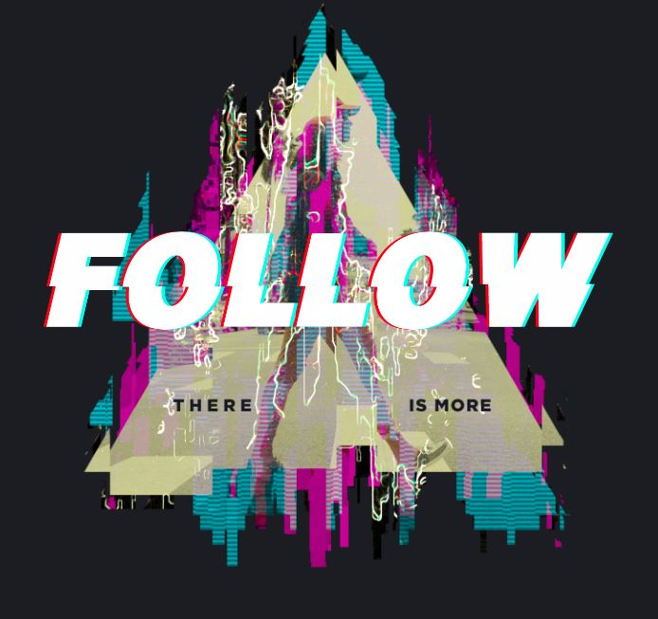

Come and have an encounter with God.
He wants to do more in and through you.
Become one of the next generation of
Church Leaders!

December 27th to the 31st
For more info contact Russell Izzo at mailto:russizzo@gmail.com

International Wesleyan
Youth Conference

Come and have an encounter with God.
He wants to do more in and through you.
Become one of the next generation of
Church Leaders!

December 27th to the 31st
For more info contact Russell Izzo at mailto:russizzo@gmail.com

