Let’s Celebrate!
November 12th will be the five year anniversary of our services in Ticonderoga at the Best Western!
Join us as we highlight the reasons for this evangelistic outreach and the impact it has had on Ticonderoga.
There will be NO SERVICE at the Hague Campus on this Sunday because we would like to bring everyone together for this event.
Brian Kvasnica – Guest Speaker

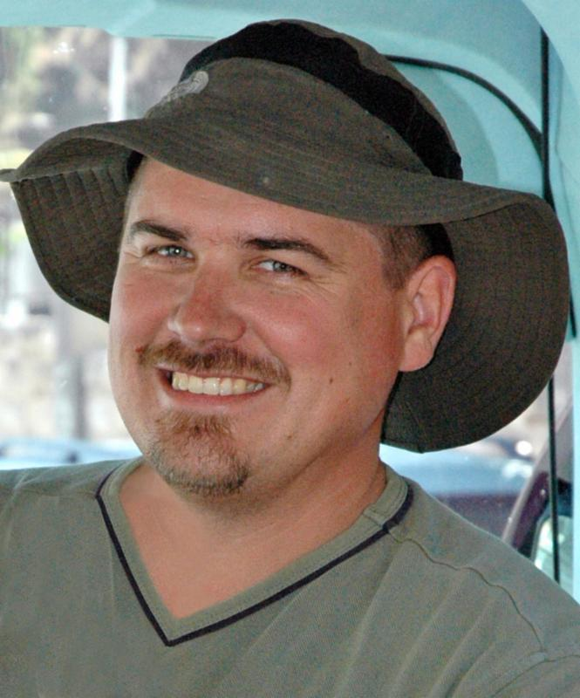
Brian, who has been called the finest Christian guide in Israel, will be our guest speaker. Brian led the study tour in Israel and Jordan that Pastor Skip and Janet joined early this year. He has a wealth of historical and practical knowledge to share which puts the current conflicts and conditions in the Middle East in biblical perspective – a perspective that will enlarge and deepen our understanding of Christ and our Christian faith.

Kvasnica, has a PhD in Ancient Judaism from Hebrew University, and is also active in the Home for Bible Translators in Jerusalem. He and his wife, Shoshi, have seven children and live outside Jerusalem.

Let’s Celebrate!
November 12th will be the five year anniversary of our services in Ticonderoga at the Best Western!
Join us as we highlight the reasons for this evangelistic outreach and the impact it has had on Ticonderoga.
There will be NO SERVICE at the Hague Campus on this Sunday because we would like to bring everyone together for this event.
Brian Kvasnica – Guest Speaker

Brian, who has been called the finest Christian guide in Israel, will be our guest speaker. Brian led the study tour in Israel and Jordan that Pastor Skip and Janet joined early this year. He has a wealth of historical and practical knowledge to share which puts the current conflicts and conditions in the Middle East in biblical perspective – a perspective that will enlarge and deepen our understanding of Christ and our Christian faith.

Kvasnica, has a PhD in Ancient Judaism from Hebrew University, and is also active in the Home for Bible Translators in Jerusalem. He and his wife, Shoshi, have seven children and live outside Jerusalem.

