Awaken the Dawn Prayer Weekend!
On the National Mall in Washington DC

This weekend, people from all backgrounds, and all 50 states are gathered together, not around speakers but around the presence of GOD. Because the impossible is easy for God, we are asking Him to heal our nation, our states and our region.
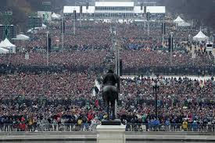

Lakeside Regional Church has a team on the ground in the New York State tent on the Mall!

Pastor Skip and our praise and worship team will be leading worship in the New York State tent as we worship here today.

So today’s service is special and we ask for your support and prayers as we lift our voices to God for our Region here in the Adirondacks
Awaken the Dawn Prayer Weekend!
On the National Mall in Washington DC

This weekend, people from all backgrounds, and all 50 states are gathered together, not around speakers but around the presence of GOD. Because the impossible is easy for God, we are asking Him to heal our nation, our states and our region.

Lakeside Regional Church has a team on the ground in the New York State tent on the Mall!

Pastor Skip and our praise and worship team will be leading worship in the New York State tent as we worship here today.

So today’s service is special and we ask for your support and prayers as we lift our voices to God for our Region here in the Adirondacks

